**1)A**

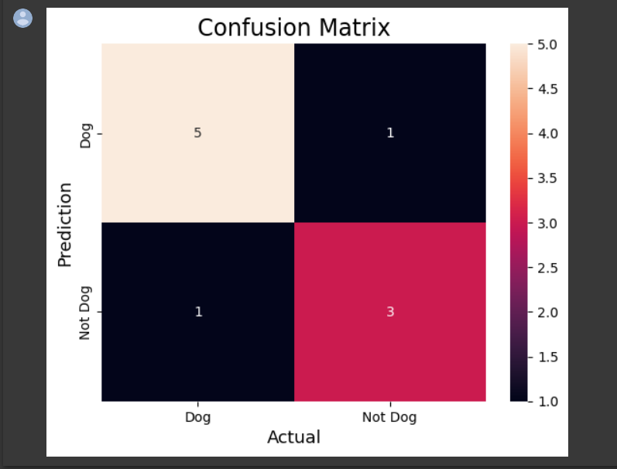

**1)B**

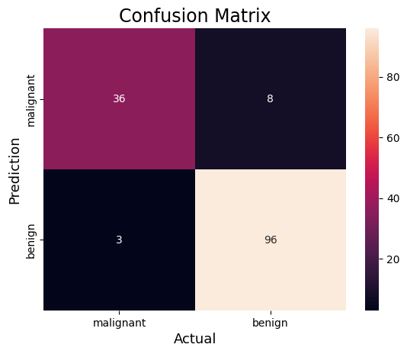

Accuracy : 0.9230769230769231

Precision : 0.9230769230769231

Recall : 0.9696969696969697

F1-score : 0.9458128078817735

**2)**

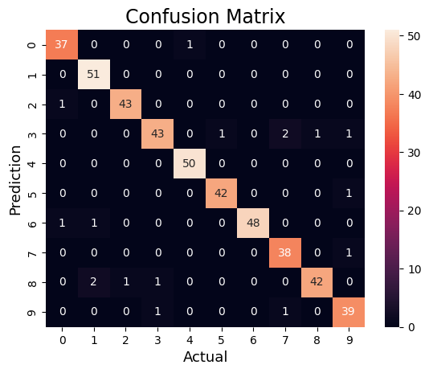

Accuracy : 0.9622222222222222

**3)**

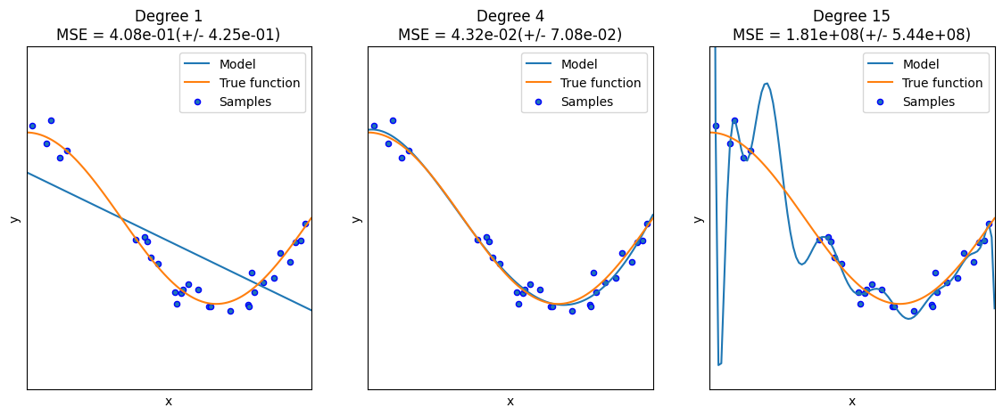

**4)**

Estimated coefficients:

b_0 = 1.2363636363636363

b_1 = 1.1696969696969697

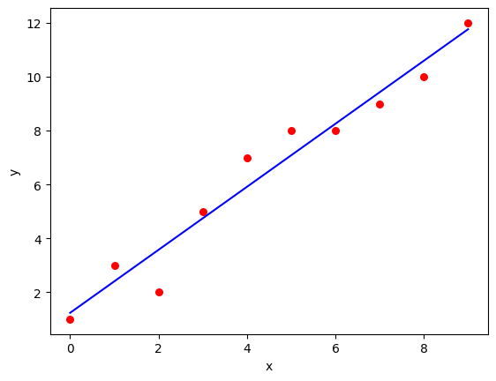

**5)**

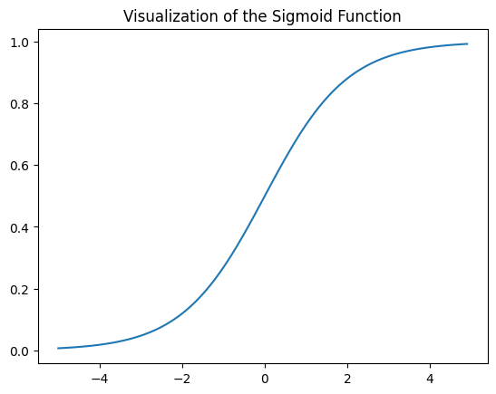

**6) A**

[[10 0 0]

[ 0 7 2]

[ 0 0 11]]

0.9333333333333333

**6) B**

[[14 0 0]

[ 0 13 1]

[ 0 4 6]]

0.868421052631579

**6) C**

[[16 0 0]

[ 0 14 1]

[ 0 0 14]]

0.9777777777777777

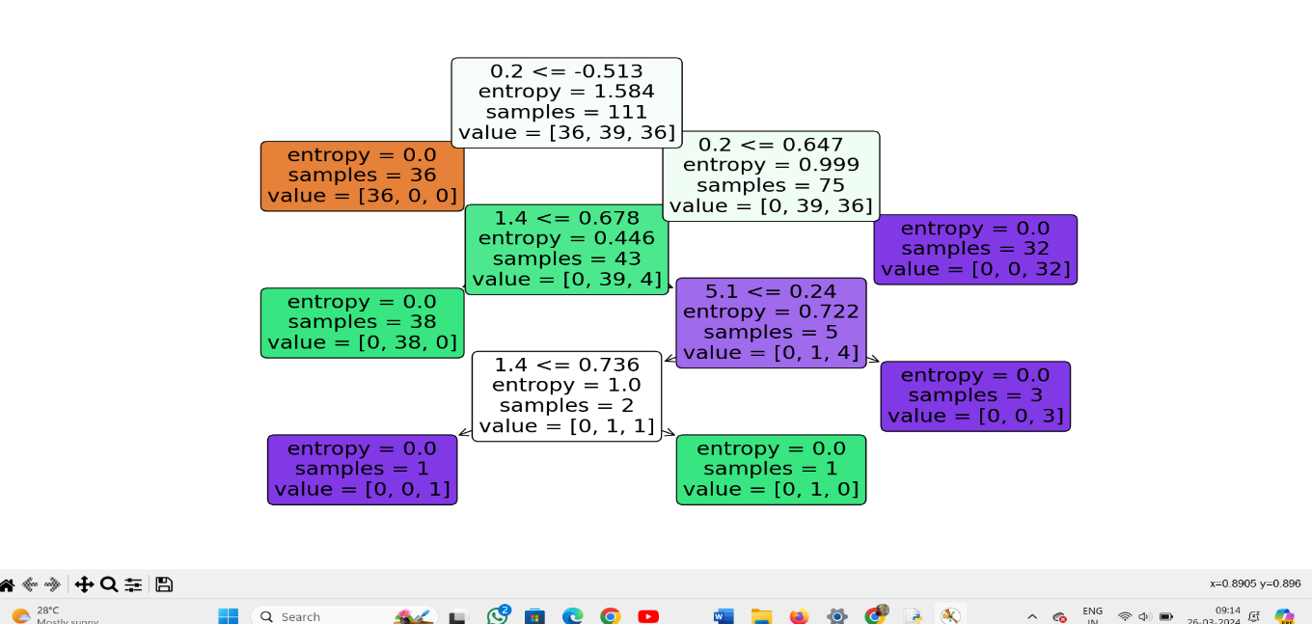

**6) D**

[[13 0 0]

[ 0 9 2]

[ 0 0 14]]

0.9473684210526315

**6) E**

[[16 0 0]

[ 0 8 3]

[ 0 0 11]]

Accuracy: 92.11%

**6) F**

[[11 0 0]

[ 0 13 1]

[ 0 0 13]]

Accuracy: 0.9736842105263158

**7)**

Iteration 1: Cost 4352.088931274409, Weight 0.7593291142562117, Bias 0.02288558130709

Iteration 2: Cost 1114.8561474350017, Weight 1.081602958862324, Bias 0.02918014748569513

Iteration 3: Cost 341.42912086804455, Weight 1.2391274084945083, Bias 0.03225308846928192

Iteration 4: Cost 156.64495290904443, Weight 1.3161239281746984, Bias 0.03375132986012604

Iteration 5: Cost 112.49704004742098, Weight 1.3537591652024805, Bias 0.034479873154934775

Iteration 6: Cost 101.9493925395456, Weight 1.3721549833978113, Bias 0.034832195392868505

Iteration 7: Cost 99.4293893333546, Weight 1.3811467575154601, Bias 0.03500062439068245

Iteration 8: Cost 98.82731958262897, Weight 1.3855419247507244, Bias 0.03507916814736111

Iteration 9: Cost 98.68347500997261, Weight 1.3876903144657764, Bias 0.035113776874486774

Iteration 10: Cost 98.64910780902792, Weight 1.3887405007983562, Bias 0.035126910596389935

Iteration 11: Cost 98.64089651459352, Weight 1.389253895811451, Bias 0.03512954755833985

Iteration 12: Cost 98.63893428729509, Weight 1.38950491235671, Bias 0.035127053821718185

Iteration 13: Cost 98.63846506273883, Weight 1.3896276808137857, Bias 0.035122052266051224

Iteration 14: Cost 98.63835254057648, Weight 1.38968776283053, Bias 0.03511582492978764

Iteration 15: Cost 98.63832524036214, Weight 1.3897172043139192, Bias 0.03510899846107016

Iteration 16: Cost 98.63831830104695, Weight 1.389731668997059, Bias 0.035101879159522745

Iteration 17: Cost 98.63831622628217, Weight 1.389738813163012, Bias 0.03509461674147458

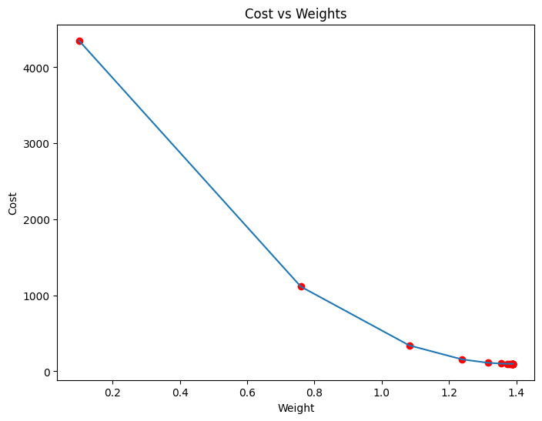

Estimated Weight: 1.389738813163012

Estimated Bias: 0.03509461674147458

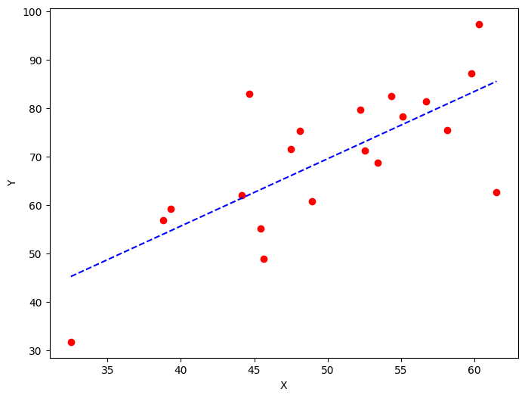

Estimated Weight: 1.272888252198252

Estimated Bias: 0.9558815898740776

**7)B**

999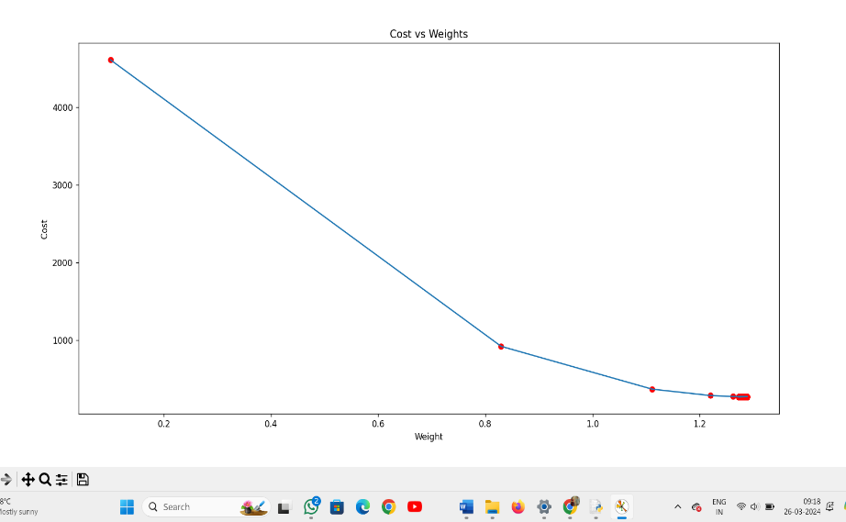

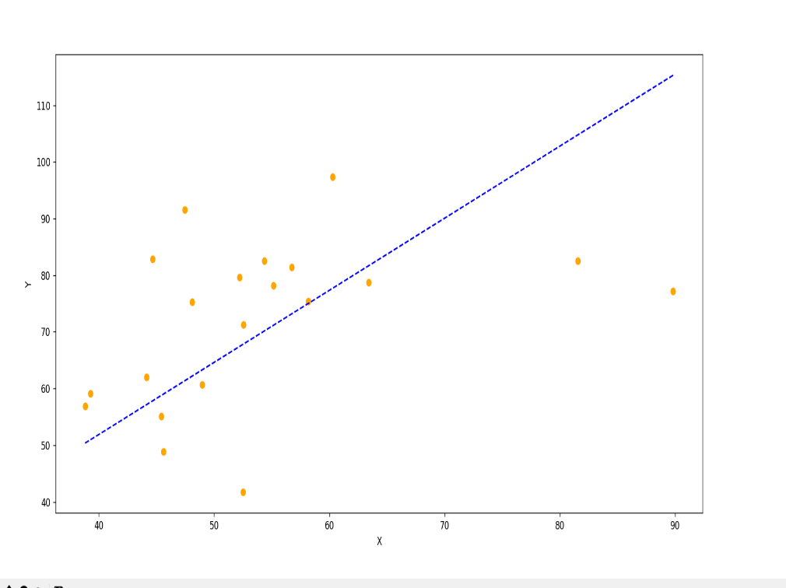

**8)A**

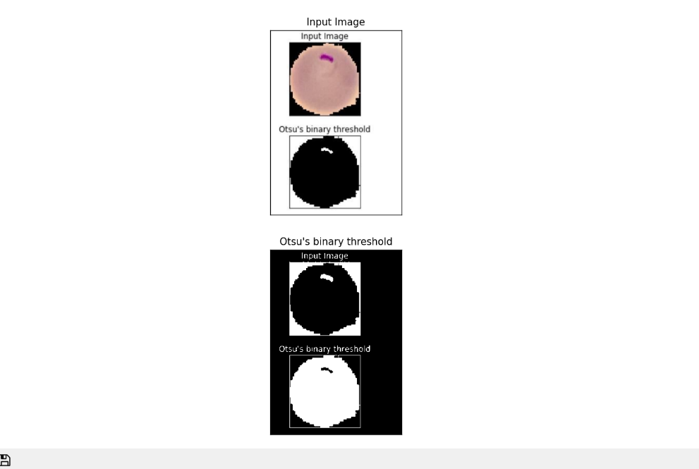

**8)B**

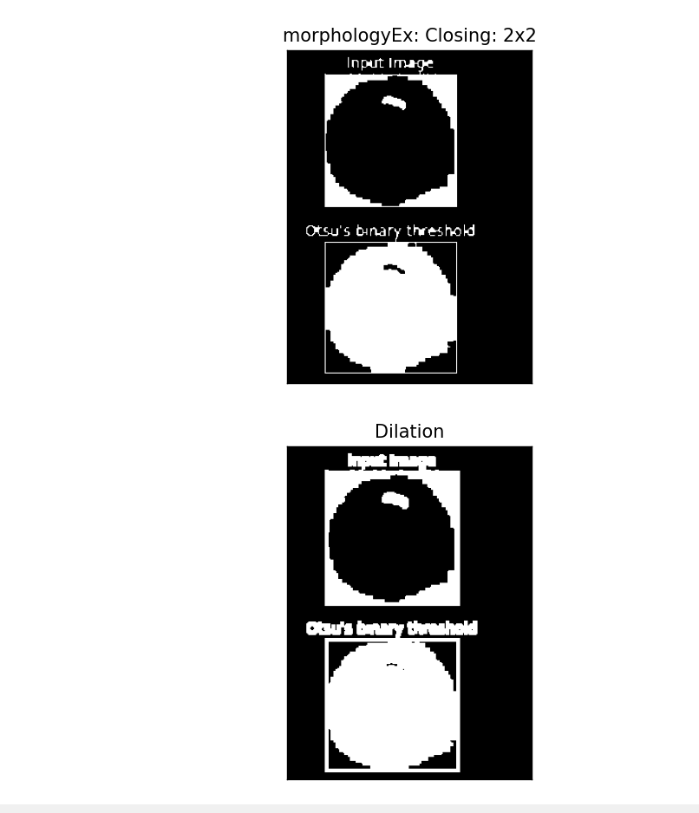

**10)**

Estimated coefficients:

b_0 = 1.2363636363636363

b_1 = 1.1696969696969697

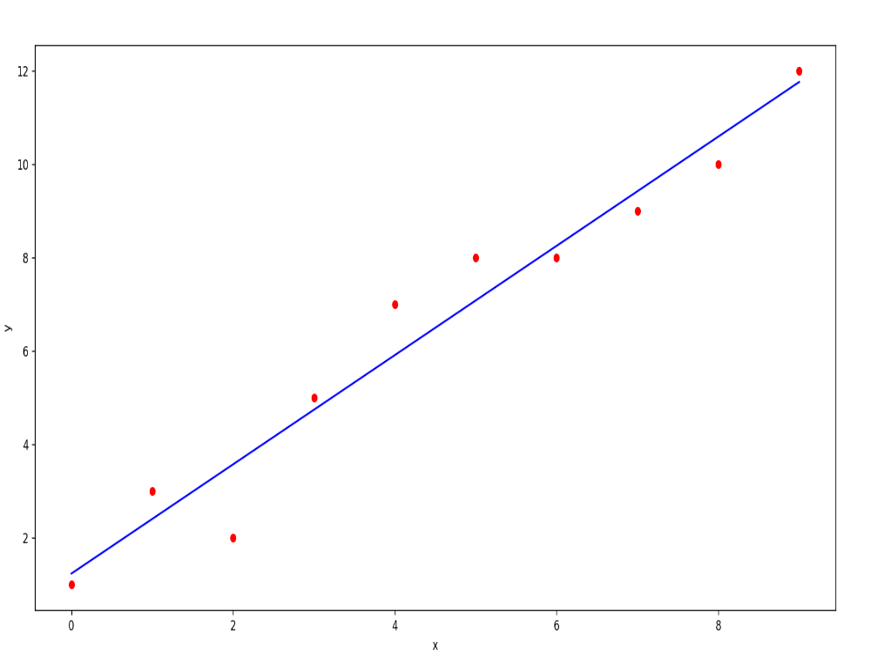

**9)A - TANH:**

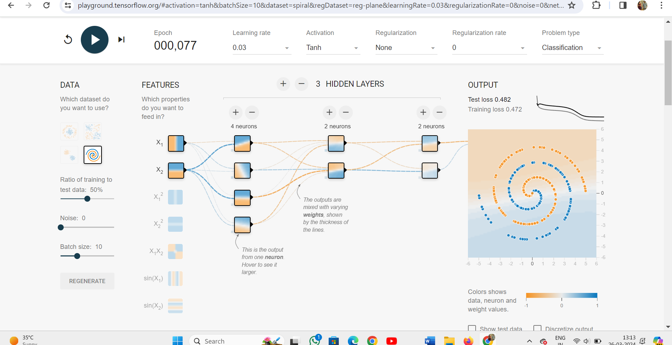

**9)B - SIGMIOD:**

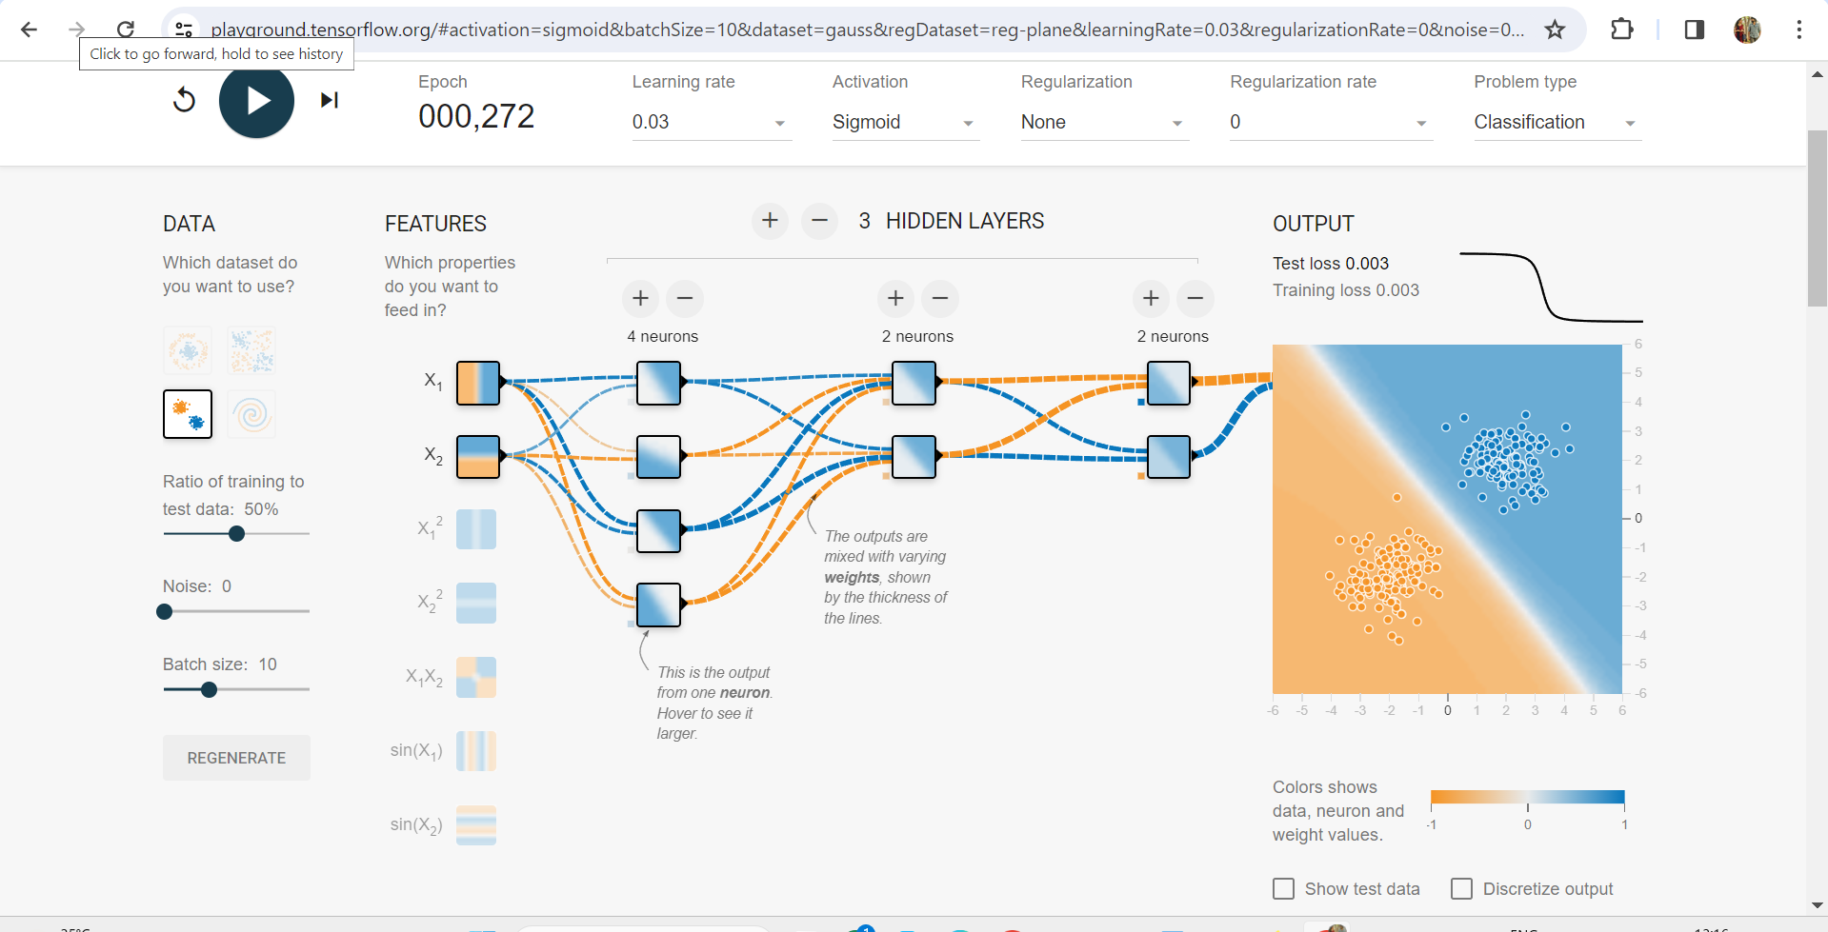

**9)C - LNEAR:**

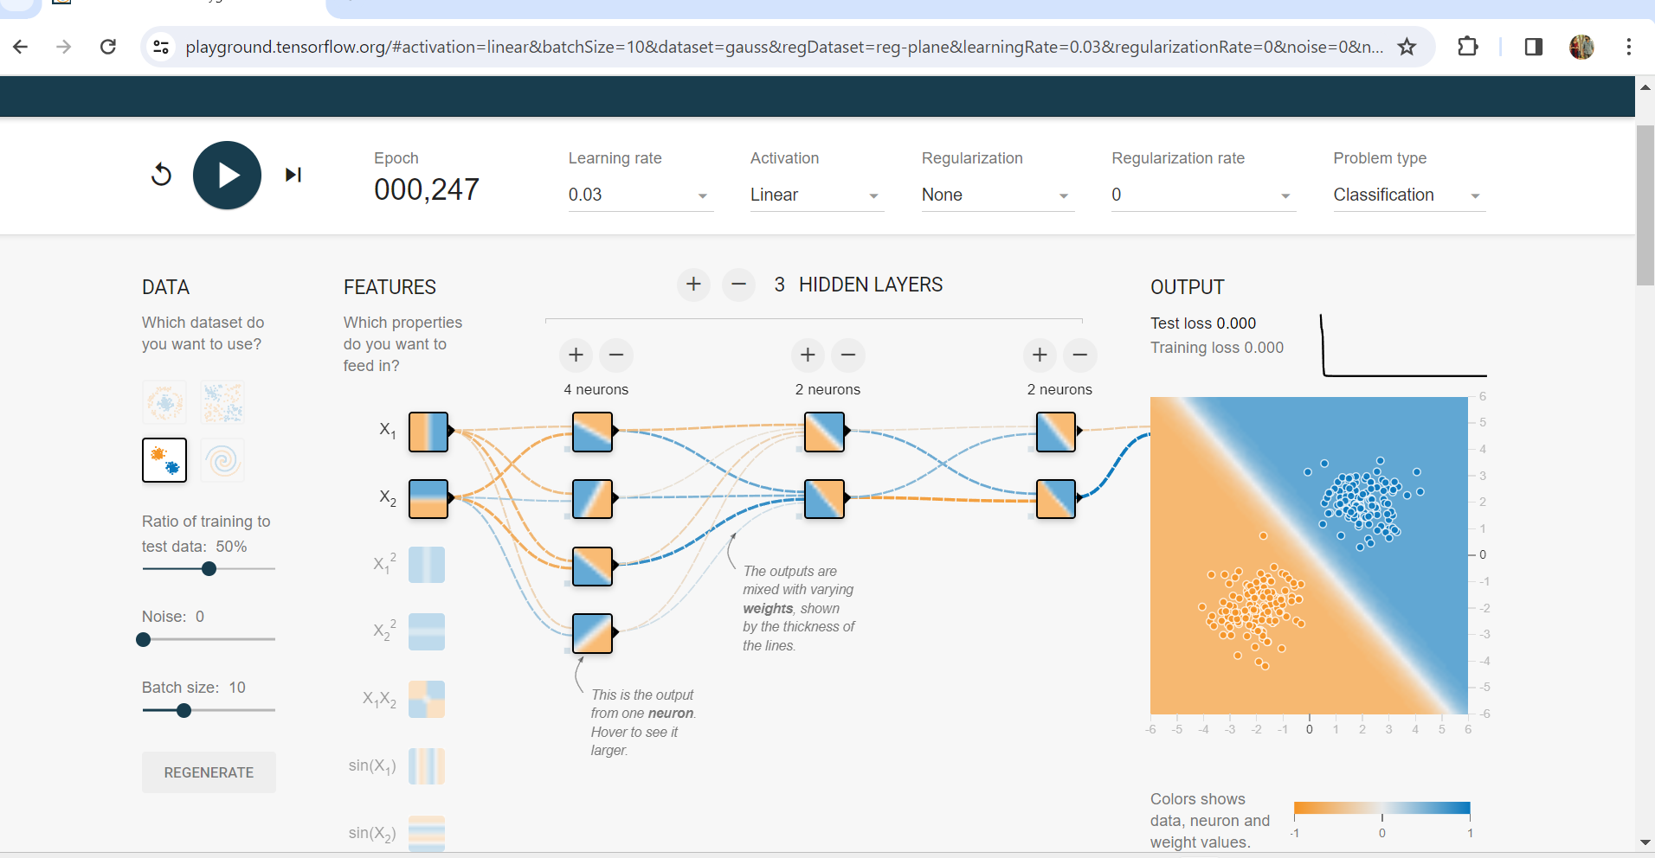

**9)D - RELU:**

